[Computer Networks 84 (2015) 76–93](http://dx.doi.org/10.1016/j.comnet.2015.04.010)

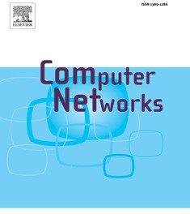

Contents lists available at [ScienceDirect](http://www.ScienceDirect.com/)

Computer Networks

journal homepage: [www.elsevier.com/locate/comnet](http://www.elsevier.com/locate/comnet)

Mobile data traﬃc oﬄoading over Passpoint hotspots✩



Sahar Hoteita,∗, Stefano Seccib, Guy Pujolleb, Adam Wolisz c, Cezary Ziemlickid,

Zbigniew Smoreda d

a *Laboratoire des Signaux et Systèmes (L2S, UMR CNRS 8506), CNRS - CentraleSupélec - Université Paris-Sud, 3, rue Joliot Curie, 91192,*

*Gif-sur-Yvette*

b *Sorbonne Universités, UPMC Universités Paris 06, UMR 7606, LIP6, Paris, F-75005, France*

c *Technical University Berlin, Berlin 10587, Germany*

d *Orange Labs, 92794 Issy les Moulineaux, France*

## a r t i c l e i n f o a b s t r a c t

*Article history:*

Received 22 August 2014

Revised 3 April 2015

Accepted 17 April 2015

Available online 30 April 2015

*Keywords:*

Mobile data traﬃc Passpoint

Traﬃc oﬄoading

Wi-Fi technology has always been an attractive solution for catering the increasing data de- mand in mobile networks because of the availability of Wi-Fi networks, the high bit rates they provide, and the lower cost of ownership. However, the legacy WiFi technology lacks of seam- less interworking between Wi-Fi and mobile cellular networks on the one hand, and between Wi-Fi hotspots on the other hand. Nowadays, the recently released Wi-Fi Certiﬁed Passpoint Program provides the necessary control-plane for these operations. Service providers can henceforth look to such Wi-Fi systems as a viable way to seamlessly oﬄoad mobile traﬃc and deliver added-value services, so that subscribers no longer face the frustration and aggrava- tion of connecting to Wi-Fi hotspots. However, the technology being rather recent, we are not aware of public studies at the state of the art documenting the achievable gain in real mobile networks. In this paper, we evaluate the capacity and energy saving gain that one can get by oﬄoading cellular data traﬃc over Passpoint hotspots as a function of different hotspot place- ment schemes and of access point selection policies (two enabled by the Passpoint control- plane and one independent of it). We compare the policies using real mobile data from the Orange network in Paris. We show that oﬄoading using Passpoint control-plane information can grant up to 15% capacity gain and 13% energy saving gain with respect to Passpoint-agnostic ones based on signal quality information. As of placement strategy, installing Passpoint hotspots in the outer annulus of the macrocell coverage grants the maximum capacity gain.

© 2015 Elsevier B.V. All rights reserved.

#### Introduction

Mobile data traﬃc continues its tremendous growth path, with an increasing number of smartphones, tablets and

✩ A preliminary version of this paper has appeared in the proceedings of the ACM International Workshop on Wireless and Mobile Technologies for Smart Cities WiMobcity, PA, USA, 2014 [1].

∗ Corresponding author. Tel.: +33 1 44 27 88 43.

[*E-mail addresses:* sahar.hoteit@lss.supelec (S. Hoteit),](mailto:stefano.secci@upmc.fr) [stefano.secci@upmc.fr (S. Secci), guy.pujolle@upmc.fr (G. Pujolle),](mailto:wolisz@tkn.tu-berlin.de) [wolisz@tkn.tu-berlin.de (A. Wolisz), cezary.ziemlicki@orange.com (C. Ziemlicki),](mailto:cezary.ziemlicki@orange.com) [zbigniew.smoreda@orange.com](mailto:zbigniew.smoreda@orange.com) [(Z. Smoreda).](mailto:cezary.ziemlicki@orange.com)

high-end handsets requiring ubiquitous Internet access. As a side effect of this mobile data explosion, we face nowadays the challenge of managing traﬃc overloads in cellular networks. According to the technical report [2], mobile data traﬃc will grow at a compound annual growth rate of 66% from 2012 to 2017, reaching 11.2 Exabytes per month by 2017. In order to meet mobile Internet demand while addressing the lack of available mobile spectrum and the expense of new infrastructure, service providers are severely challenged. They need to master the needed capacity expansion in their backhauling network, otherwise the data traﬃc will sooner or later clog their networks. Next-generation network deployments promise to deliver

<http://dx.doi.org/10.1016/j.comnet.2015.04.010> 1389-1286/© 2015 Elsevier B.V. All rights reserved.

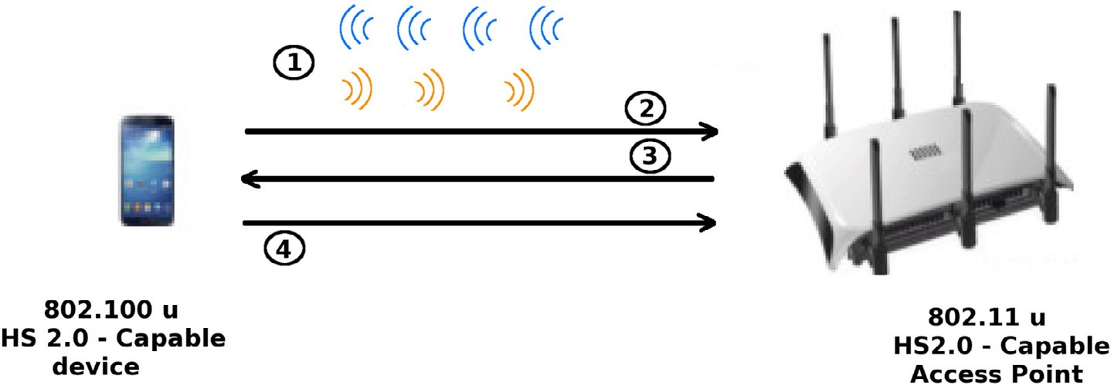

**Fig. 1.** Passpoint hotspot association.

higher bandwidth and speed, but they often imply high capital and operational expenditures [3].

An alternative economically and technically viable way is represented by mobile data oﬄoading solutions. Such so- lutions aim to optimize the resource utilization reducing the traﬃc on operator’s licensed spectrum, and lowering the traf- ﬁc load on base stations. Wi-Fi technology has always been an attractive solution for data oﬄoading because of the ubiquity of Wi-Fi networks, the high bit rates they provide, the sim- plicity in deployment and maintenance, and the lower CAPEX [4]. Until the Wi-Fi Certiﬁed Passpoint Program (also known as ‘Hotspot 2.0’ and referred to in the following shortly as ‘Passpoint’) [5], the WiFi technology was lacking of seamless interworking between Wi-Fi and mobile cellular networks on the one hand and between Wi-Fi hotspots on the other hand. The new Passpoint program aims to make the WiFi network a “true extension of service provider networks”, letting users roam from one hotspot to another with no manual effort, just like cell phone network that already switches seamlessly from one cell tower to another. The Passpoint technology provides all control-plane functionalities for automated and seamless connectivity to Wi-Fi hotspots. With Passpoint, ser- vice providers can look to such advanced Wi-Fi systems as a viable way to oﬄoad traﬃc and deliver high-bandwidth ser- vices. At the same time, subscribers no longer have to face the frustration and service degradation typically experienced when connecting to legacy Wi-Fi hotspots.

As a matter of fact, Passpoint can work in any network and

overcomes the limitations of proprietary, non-interoperable solutions offered by some providers today. Devices certiﬁed in the Passpoint program will be able to manage network as- sociation, authentication, sign-up, and security in the back- ground, in a way that is completely transparent to the sub- scriber and that consistently works in any Passpoint network [6,8]. When a user with a “Hotspot 2.0” (HS2.0) capable mo- bile device (i.e., based on IEEE 802.11u) comes within the range of a HS2.0 capable hotspot, it will automatically open up a dialog with that hotspot to determine its capabilities before proceeding to authentication. It is worth noting that Passpoint logic is already implemented in many mobile de-

In this paper, we evaluate mobile data traﬃc oﬄoad- ing over Passpoint hotspots by determining the obtainable capacity gain and energy saving gain in dense urban envi- ronment.1 For the assessment, we use real Orange cellular network dataset retrieved by probes capturing mobile data sessions’ details, and we compare different hotspot selec- tion policies enabled by Passpoint with each other and with a Passpoint-agnostic policy based on signal quality metrics. Basic Passpoint policies can be based on the least utilized channel or the least number of attached users. The Passpoint- agnostic policy is one selecting the hotspot with the highest signal to noise ratio. We ﬁnd out that oﬄoading using Pass- point control-plane information can grant up to 15% capacity gain and 13% energy saving gain with respect to Passpoint- agnostic ones based on signal quality information. Moreover, we show that installing Passpoint hotspots in the outer annu- lus of the macrocell coverage permits to increase the oﬄoad- ing system capacity and system performance. The paper is organized as follows. Section 2 presents Passpoint and gives an overview of related works. Section 3 synthetically presents the available dataset and reports data traﬃc consumption and users characteristics. Section 4 describes the oﬄoading over Passpoint approach, followed by a presentation of simulation results in Section 5. Finally, Section 6 concludes the paper.

#### Background

In the following, we ﬁrst give an insight on the hotspot- device signaling information exchanged with Passpoint, and then we provide an overview of relevant work on the matter at the state of the art.

* 1. *Passpoint hotspot-device signaling*

Fig. 1 illustrates the four different required steps for Pass- point hotspot association. The Access Network Query Proto- col (ANQP) is used for device-hotspot signaling [5].

vices, such as Android-based ones. Moreover, since Passpoint

discovery is based on pre-authentication, there are consid- erable savings of time and battery life compared to existing methods [5].

1 With respect to [1], this paper gives a more detailed modeling, more

details on the algorithmic and protocol frameworks, and describes new sim- ulation results, also evaluating mixed oﬄoading policies, comparing the dif- ferent solutions in terms of fairness and of energy gain.

**Table 1**

Beacon and probe response information elements in Passpoint.

*Access Network Type* Identiﬁes whether hotspot is for

public, private or guest access.

*Internet Bit* Indicates if the hotspot can be used for Internet access.

*Advertisement Protocol* Indicates if the hotspot supports

Generic Advertisement Service (GAS)

and Access Network Query Protocol (ANQP).

*Roaming Consortium* element Provides a list of up to 3 names

of reachable service providers.

*Venue Information* Describes the type of venue (i.e., whether it is

a restaurant, a stadium, a library, etc.) where the hotspot is situated.

*Load Element* Provides information on channel

utilization and the current number of associated devices.

* + 1. The 802.11u-capable access point broadcasts its HS2.0 support, so that HS2.0-enabled devices can recognize such support.
    2. The 802.11u-capable device is able to process ANQP mes- sages, containing useful information such as the ‘reach- able’ authenticators, and various hotspot capabilities. The 802.11u-capable device requests full authenticators list.
    3. The hotspot responds to the ANQP query with the re- quested information.
    4. Device compares provisioned network-selection policy with HS2.0 data from hotspots and associates itself to the best hotspot suitable for its needs.

Table 1 shows some of the information elements provided by the hotspot to the mobile devices. In the speciﬁcations, those six elements are mentioned. Most elements provide simple conﬁguration and network reachability and locality information. The most interesting element for eﬃcient Pass- point selection is the Load Element, which allows a mobile de- vice to be informed about hotspot channel utilization and the current number of associated devices to a Passpoint hotspot. We note that it may be possible for a mobile device to decide whether to use a hotspot based just on the infor- mation in beacons and probe responses. A quick scan al- lows the device to build a list of Passpoint-capable access points, whether they provide Internet access and a list of service providers available via that hotspot. It is worth men- tioning that passive radio use (i.e., listening for beacons) is less battery-consuming than active probing where frames are transmitted, but the long interval between beacons (usu- ally around 100 ms) means that in practice, devices follow an active-scan regime, with an interval of 15 s or more. Passpoint allows probe requests to be directed: for instance, if a ﬂag is set in the probe request, only those access points supporting Internet access will respond. This reduces frames on the air and potentially means the mobile device can spend less time

listening for responses.

* 1. *Related works*

The increasing need of oﬄoading solutions is caused by the explosion of Internet data traﬃc, especially the growing portion of traﬃc going through mobile networks. For these reasons, different studies and researches tackling mobile data oﬄoading have been conducted in the past few years to alle-

viate the traﬃc load on cellular networks. We present in the following some of the oﬄoading approaches proposed thus far. Wi-Fi and femtocell technologies are considered the pri- mary oﬄoad technologies considered today by the industry stakeholders.

* + 1. *Horizontal data oﬄoading*

The femtocell technology [9,10], also referred to as small- cells technology, aims to offer better indoor voice and data services for cellular networks via the deployment of tiny cellular repeaters, differently backhauled and synchronized. Femtocell services are already commercialized to expand cell coverage and improve radio resource management [11]. Fem- tocells work on the same licensed spectrum as the macrocells of cellular networks and thus do not require special hardware support on mobile phones, thus simplifying data oﬄoading procedures. But, despite the beneﬁts of femtocells networks in oﬄoading data traﬃc via horizontal handovers from macro to femto cells and vice versa, one should not forget the in- herent constraints of such networks due to cross-tier and co-tier interferences that should be taken into account when installing femtocells [12].

The cross-tier interference [13] is deﬁned as the decrease in signal quality of macrocell users due to the presence of femto users sharing the same spectrum and vice versa, and the co-tier interference occurs when all femtocells share the same spectrum. Advanced resource scheduling and alloca- tion techniques have been deﬁned for both spectrum man- agement situations, such as [14] for cross-tier and [15,16] for co-tier interference. Despite the promising results therein in terms of achievable performance, those approaches either require a form of explicit coordination and signaling among femtocells or group of femtocells, or some sort of centraliza- tion to collect necessary multi-cell information at one com- puting place (e.g., using Cloud Radio Access Network, C-RAN, solutions [17]). In either case, an important level of com- plexity and signiﬁcant investments need to be undertaken to implement this type of oﬄoading management.

* + 1. *Vertical data oﬄoading*

A much simpler, inexpensive and lightweight solution consists of using Wi-Fi hotspots for data oﬄoading. The key advantage of oﬄoading to Wi-Fi hotspots is that they operate over unlicensed spectrum, thus no interference management

is required between macrocell and Wi-Fi hotspots. In addi- tion, the installation of Wi-Fi hotspots is easier and more cost effective than large cellular network deployments and up- grades. The main problem that was facing the industry with Wi-Fi is that it is used only for ﬁxed access. Nevertheless, nowadays with the Passpoint program this problem is over- come; in other terms, this new standard enables seamless hopping from hotspot to hotspot and even vertical handoffs across cellular and Wi-Fi networks without the user being aware of it [5,6]. Overall, we can say that the Passpoint tech- nology combines the advantages of both Femtocell technol- ogy (in terms of simplifying data traﬃc oﬄoading) and WiFi technology (in terms of mobility management), thus it helps the operators to facilitate data traﬃc oﬄoading.2

Likely because of its recent speciﬁcation, the scientiﬁc pa- pers discussed from the literature do not consider the Pass- point technology explicitly along with its hotspot selection capabilities. We present thereafter a selection of Wi-Fi of- ﬂoading strategies available in the literature.

Authors in [7] quantify city-wide Wi-Fi oﬄoading gain. They show that even a sparse Wi-Fi network improves per- formance. Similarly, authors in [18] measure the oﬄoading potential of the public WiFi based on city wide vehicular traces. Compared to the vehicle based high mobility scenario in [18], the authors in [19] study the performance of 3G mo- bile data oﬄoading through Wi-Fi networks in a more general mobile scenario with empirical pedestrian traces. They dis- tinguish two different types of Wi-Fi oﬄoading: *on-the-spot*

and *delayed* oﬄoading. The ﬁrst type consists of spontaneous

connectivity to Wi-Fi and transfer data on the spot; when users move outside the Wi-Fi coverage area, the oﬄoading is stopped and all the unﬁnished transfers are transmitted back to cellular networks. In the delayed oﬄoading, each data transfer is associated with a deadline and as users come in and out of Wi-Fi coverage areas, their data transfer is repeat- edly resumed until the transfer is complete or the deadline is reached. Based on a study done over some smartphones users and on the statistical distributions of their Wi-Fi con- nectivity, the authors evaluate the Wi-Fi oﬄoading eﬃciency for various amount of Wi-Fi deployment, different deploy- ment strategies, different traﬃc intensity and delay dead- lines, showing that Wi-Fi in such conﬁgurations can oﬄoad up to 65% of the total mobile data traﬃc. Authors in [20] con- sider the traﬃc ﬂow characteristics and types when deciding to oﬄoad data traﬃc to Wi-Fi networks. They check the suit- ability of traﬃc to be oﬄoaded over WiFi access points as a function of four different selection schemes: the received sig- nal strength indicator that consists of oﬄoading those users having the lowest signal strength, random selection that se- lects terminals randomly, ineﬃciency where we select the users or traﬃc ﬂows that contribute signiﬁcantly to the load in the access network but beneﬁt only marginally from these expenditures and ﬁnally the equal weight selection scheme that takes into account both the ineﬃciency and the chan- nel utilization factors. They show that the last two schemes outperform the others in terms of oﬄoaded data traﬃc vol- ume and number of traﬃc ﬂows for different network cases.

2 It is worth-mentioning that a WiFi access point can be simply trans- formed into a Passpoint-enabled access point by an operating system or ﬁrmware upgrade and does not require special hardware support.

Authors in [21] explore the beneﬁts in terms of energy sav- ings that can be achieved by oﬄoading traﬃc loads to Wi-Fi networks. Using different traﬃc types, they show that a sav- ing of up to 70% is reached by opportunistically powering down cellular radio network equipment to oﬄoad users traf- ﬁc to Wi-Fi hotspots.

In [22], a WiFi oﬄoading scheme is proposed from a trans- port layer perspective. A multipath protocol called oSCTP is proposed to oﬄoad the 3G traﬃc via WiFi networks and maxi- mize the user’s beneﬁt. The philosophy of oSCTP is to use WiFi and 3G interfaces simultaneously if necessary, and schedule packets transmitted in each interface every schedule inter- val. By modeling user utility and cost both as a function of the 3G and WiFi network usage, the user’s beneﬁt, i.e., the differ- ence between the utility and the cost, is maximized through an optimization problem. Following the same direction, the authors in [23] propose a framework for 3G traﬃc oﬄoading based on the idea of motivating mobile users with high delay tolerance to oﬄoad their traﬃc to Wi-Fi networks. A feasible approach consists of delaying all delay tolerant applications until their maximum delay tolerance, and then resorting to the cellular networks if the applications cannot ﬁnish. How- ever, this approach does not appear much effective, consid- ering that the user has to wait even when there is actually no available Wi-Fi connection. To solve this problem, the au- thors in [24] propose an adaptive approach that computes an oﬄoad handing-back time, after which the user stops waiting for oﬄoading through Wi-Fi connections, hence resorting to the cellular network service. This allows achieving a better trade-off between oﬄoaded volume and user satisfaction. A combination of different radio access technology is applied in [25] in which several radio access technology selection principles based on the signal strength (coverage) and in- stantaneous load are suggested.

#### On mobile data characteristics

It is of paramount importance to have a realistic insight on real mobile data characteristics to understand the potential impact of oﬄoading techniques at large. In this section, after a brief description of the available dataset, we synthetically describe mobile data consumption characteristics.

* 1. *Cellular network dataset*

The dataset used in our study consists of network probe’s data, generated each time a mobile device uses the wireless mobile network for Internet data exchange (not for voice calls and SMS), i.e., what is commonly referred to as “mobile In- ternet” service. The probe is able to distinguish the transport protocol used for the communication (Transport Control Pro- tocol, TCP, or User Datagram Protocol, UDP) and to categorize the traﬃc by application typology. All user identiﬁers and sensible information were irreversibly anonymized by Or- ange Labs before analysis. The probe collects data with 6-min interval sessions, assigning the session to the cell identiﬁer of the last used antenna. In other terms, we determine in each 6-min interval the position of each user (i.e., the position of the last antenna to which the user is connected) as well as the data traﬃc consumption (i.e., data traﬃc volume in MB for each used application during the 6-min interval). The data are

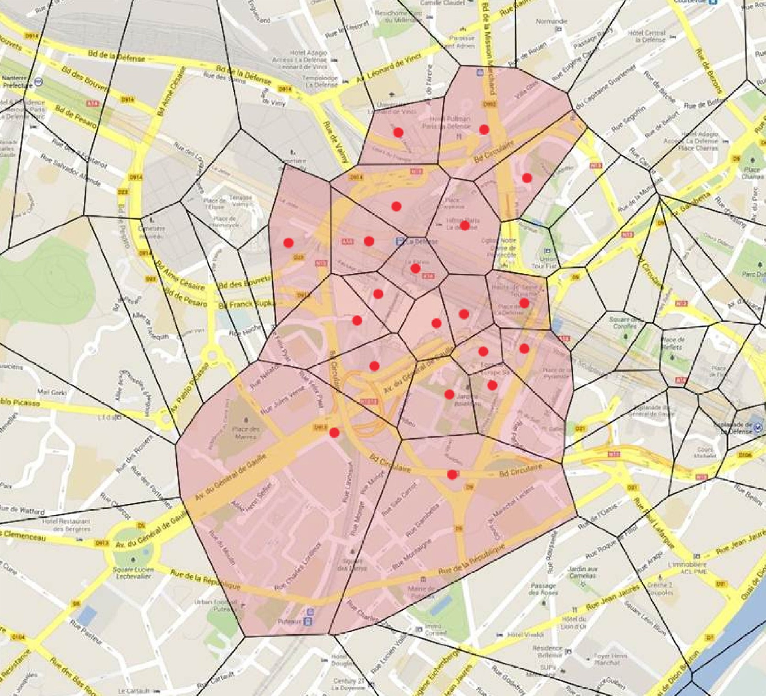

**Fig. 2.** The dataset region. (For interpretation of the references to color in this ﬁgure legend, the reader is referred to the web version of this article.)

recorded on a per user basis and cover more than 1.5 million of French mobile phone users in the Parisian metropolitan area, the “Ile-de-France”, giving about 100 million records per day.

We limit the study in the paper to the “La Defense” re- gion, a major business district in the northwest of Paris. The region of 1 km2 area, is decomposed as shown in Fig. 2 at base station level, where red dots represent the base stations and the surrounding polygons represent the Voronoi cells.3 We analyze the data in a normal working day from 8 am to 10 am when people make their regular home-to-work travel. We

3 The Voronoi cell can be determined based on the geographical position and the coverage area (determined according to power level) of the corre- sponding base station.

choose this period to capture users’ mobility in the chosen region. Upon this selection, we extract mobility patterns and data consumption of about 20,000 users. It is worth mention- ing that since we are working on a cell-based data set with 6-min interval sessions and in order to capture user’s posi- tion at each instant of time, we use the following strategy: if the user remains in the same cell in two consecutive sessions, he is considered as a non-moving user (its position is chosen randomly in the cell), however if the user changes its cell from one session to another, he is considered as moving along a lin- ear trajectory from its position in the ﬁrst cell to its position in the second cell. The latter property was indeed established based on an in-depth analysis about human trajectories by the authors of [26], where they show that for users moving short distances, the linear trajectory is the best estimation of

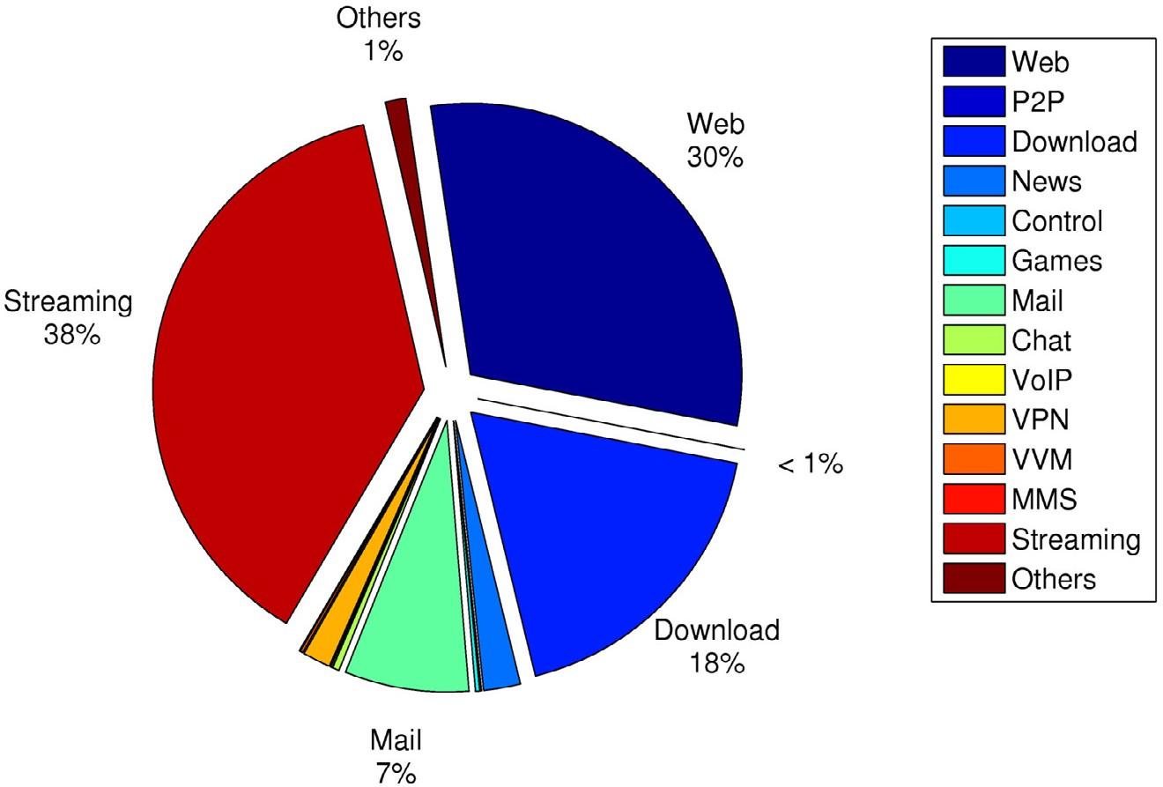

**Fig. 3.** Traﬃc consumption by application type (3% UDP, 97% TCP; video streaming is mostly over TCP).

their real trajectories. This property applies strongly in our model, as the region of study is relatively small.

* 1. *Data consumption characteristics*

Before delving into the different oﬄoading over Passpoint policies we deﬁne and analyze, we provide in this section some useful information about data consumption trends. First, we clearly highlight the most widely used applications and communication protocols. Then, we compare users con- sumption and demands. Fig. 3 represents the proportion of traﬃc generated from each application (i.e., the traﬃc vol- ume generated from each application to the total volume generated by all applications). We can clearly see that video streaming applications occupy the highest consumption por- tion (38%) among other applications. These habitudes have taken place thanks to computing enhancements in mobile handheld devices and the increasing bandwidth from high- speed mobile networks in urban environments. This trend is also expected to increase at rapid paces in the coming years with the deployment of 4G networks. By classifying the data with respect to the transport-level protocol only (i.e., TCP and UDP, used for applications needing or not, respectively, ﬂow control and packet retransmissions upon loss, so roughly corresponding to non-interactive and interactive real-time services), we ﬁnd out that TCP based applications are much more used than UDP ones (i.e., 97% of the traﬃc is TCP-based while only 3% is UDP based). It is worth noting that video streaming applications are nowadays mostly based on HTTP Live Streaming protocol (also known as HLS) [27].

Comparing users’ demands separately instead of collec-

tively, Fig. 4 plots the user demand distribution given the 6- min aggregation intervals (i.e., one cannot know through the data the instantaneous user demands because the collected data are aggregated as mentioned above). We can notice that

while 97% of users have a very low demand of less than 1 MB during the 6 min session (i.e., roughly 30 kb/s on average), we have only 1% of them with a demand of more than 100 MB (i.e., roughly 3 Mb/s on average) and the maximum demand is about 325 MB that corresponds to a mean bit rate of roughly

7.2 Mb/s.

#### Evaluation methodology of oﬄoading over passpoint

In this section, we describe the methodology we adopted to evaluate mobile data traﬃc oﬄoading over Passpoint hotspots. We draw the whole oﬄoading procedure in the ﬂow chart presented in Fig. 5.

Given a sample geographical distribution of Passpoint hotspots, we extract user displacement information from the Orange data traces. When a mobile device, connected already to the cellular network, encounters along its trajectory a Pass- point hotspot or a number of Passpoint hotspots, it starts up a dialog with these hotspots to learn about the service providers available via each of them, as well as other char- acteristics of the hotspots via the ANQP protocol. Thanks to this signaling, the mobile device can discover a comprehen- sive proﬁle of the hotspot before association, so it can quickly identify, prioritize hotspots suitable for its needs and select the best match while still in the user’s pocket. We should note that this procedure is done only when there is at least one Passpoint hotspot near the user’s location and if the user, at any time, does not enter the coverage of at least one hotspot, it remains connected to the cellular network.

The hotspot selection policy is therefore of paramount importance for both the user, able to associate to the best access point, and the network, which should avoid hotspot and backhauling link congestion. We compare in this paper three different hotspot selection policies, each taking into

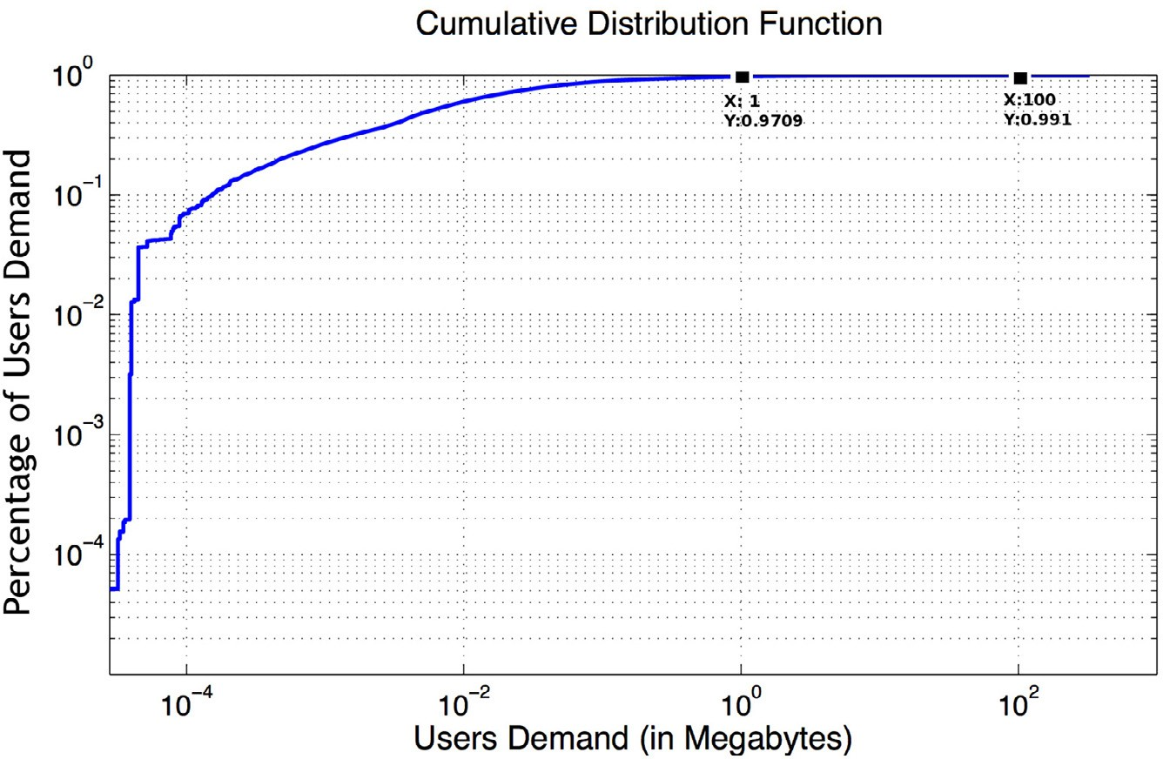

**Fig. 4.** Cumulative distribution function of users demands.

consideration one different parameter, as described in the following

1. *Number of Associated Devices*: The user is attached to the hotspot with the least number of associated devices (this information is provided by the hotspot in its response to the ANQP query as presented in Table 1).
2. *Channel Utilization*: The user is attached to the hotspot

with the least Channel Utilization deﬁned as the percent- age of time the hotspot senses the medium busy (i.e., this information is also provided by the hotspot in its response to the ANQP query). In the simulations, we compute this value for each 6-min time interval using the dataset de- scribed in Section 3. It is worth noting that this metric takes into account the traﬃc volume of the users.

1. *Signal Quality*: The user is attached to the hotspot with the

best received signal power.

While the4 ﬁrst two are retrievable information via the ANQP Passpoint signaling, the latter instead does not strictly depend on Passpoint and can be considered as a policy that could easily be implemented with a relatively limited programming of mobile device’s drivers ignoring hotspot capabilities.

After selecting the suitable hotspot, the mobile device is automatically authenticated. In Passpoint, this is done using Extensible Authentication Protocols (EAP) based on a Sub- scriber Identity Module (SIM) authentication, an authenti- cation that is widely used in cellular networks today [6]. This procedure is speciﬁed in such a way that the process is

4 A user having higher traﬃc volume than another one makes the medium busy for a longer time. Due to the limitation of details, in the public docu- mentation about the Passpoint standard, on how to compute the channel utilization exactly, we use only this small deﬁnition without taking the com- plexity into account.

completely transparent to the subscriber and that consis- tently works in any Passpoint network.

Then, the oﬄoading process starts; only delay-tolerant traﬃc is oﬄoaded to Passpoint hotspots, while retaining delay-sensitive traﬃc in mobile cellular networks. We con- sider as delay-tolerant the TCP traﬃc that can tolerate some delays. The UDP traﬃc is considered as the delay-sensitive traﬃc (i.e. real time traﬃc) that does not tolerate delays. We use a ﬁxed delay tolerance Thmax to qualify TCP traf- ﬁc: if the user reaches such delay tolerance, or moves out of the coverage of the Passpoint hotspot and ﬁnds no other hotspots in the environment, it returns back to the cellular network transparently. In the simulations, we ﬁx the Thmax to 1 min, but we evaluate the inﬂuence of varying this threshold on the performance in Section 5.5.

#### Simulation results

In this section we describe the simulation framework we adopted to evaluate different oﬄoading policies in MATLAB. We note that we use the Orange network dataset described in Section 3 for mobility patterns and traﬃc consumption. For each simulation, the Passpoint hotspots are distributed in the selected region presented in Fig. 2 of approximately 1 km2. The results are obtained over many simulation in- stances, with a margin error lower than 3%; we do not plot corresponding conﬁdence intervals for the sake of presenta- tion. In the following, we ﬁrst present the radio model then we compare different oﬄoading policies and hotspot place- ment strategies.

* 1. *Radio model*

The macrocells are assumed to operate using the OFDMA technology (e.g., in LTE) whose frame structure is based on time-frequency slots, also called tiles or resource blocks (RBs).

|  |  |
| --- | --- |
| Yes |  |
| Hotspot Se- lection Policy | |
|  |  |
| SIM Authentication | |
|  |  |
| Off loading Delay Tolerant Traffic to  the Selected Hotspot | |
|  |  |

**Fig. 5.** Oﬄoading algorithm.

Within the coverage of at

least one Passpoint hotspot?

No

User

remains within

Passpoint’s coverage?

Yes

No

No

Is TCP

traffic

completely offloaded?

yes

END

User connects back to the cellular network

User is moving

**Table 2**

Typical parameters for downlink transmis- sion.

Transmission bandwidth [MHz] 20 Number of resource blocks 100

OFDMA symbols per 1 ms 14

Modulation symbol rate (Mb/s) 16.8

QPSK bit rate (Mb/s) 33.6

16QAM bit rate (Mb/s) 67.2

64QAM bit rate (Mb/s) 100.8

A set of parameters for typical transmission bandwidths for LTE in the downlink is shown in Table 2, where the subcarrier spacing is *Of* = 15 kHz. We select 20 MHz as the transmis-

sion bandwidth, therefore the number of resource blocks per frame is equal to 100 RBs, e.g., allowing a max throughput of

* 1. Mb/s for the 64 QAM modulation.

These parameters are used to compute user demands in terms of RBs knowing only the volume in bytes. We note here that the modulation used by each user depends on its signal to noise plus interference (SINR) level.5 We use the COST- 231 Hata path loss model [28], devised as an extension to the Okumura–Hata model, which is the most widely used ra- dio frequency propagation model for predicting the behavior

5 For each SINR level, a modulation is selected from those presented in Table 2.

**Table 3**

Channel overlapping degree.

|  |  |  |  |  |  |  |  |  |
| --- | --- | --- | --- | --- | --- | --- | --- | --- |
| Channel distance | 0 | 1 | 2 | 3 | 4 | 5 | 6 | S 7 |
| Overlapping degree | 1 | 0.7272 | 0.2714 | 0.0375 | 0.0054 | 0.0008 | 0.0002 | 0 |

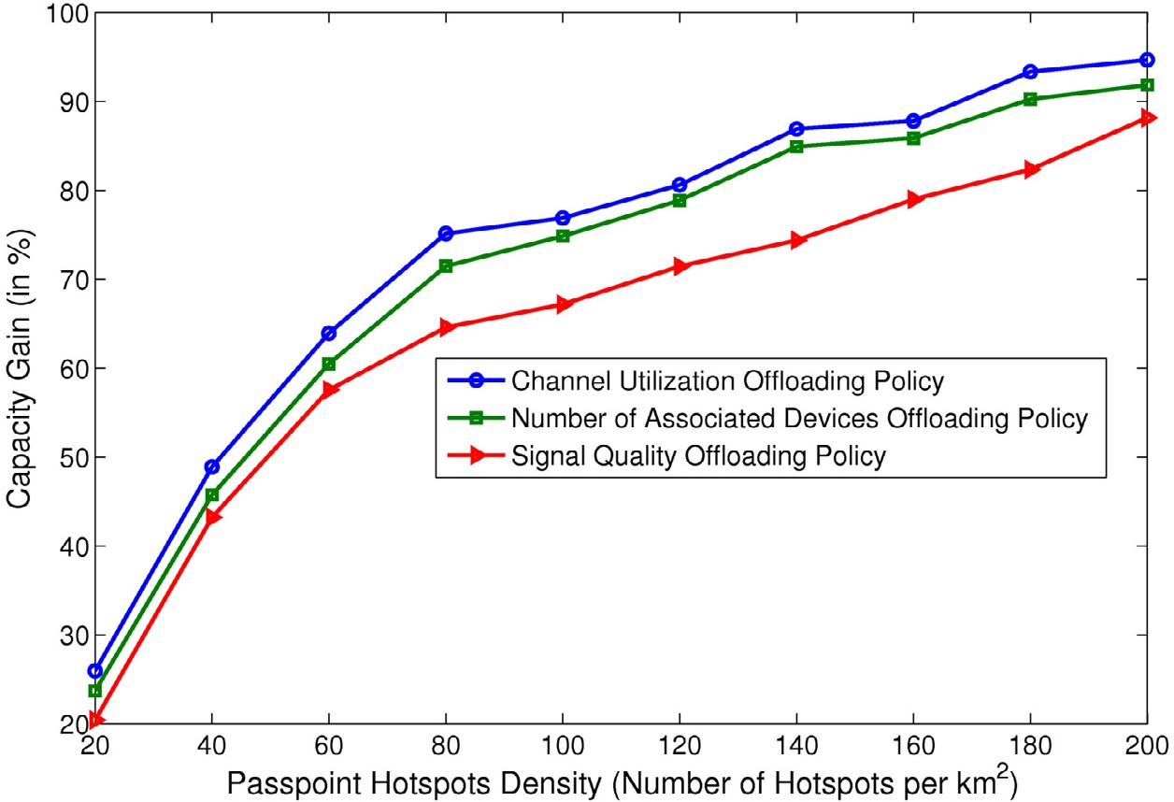

**Fig. 6.** Capacity gain for different Passpoint hotspot selection policies.

of cellular transmissions in urban areas [29]. Moreover, we model the non-deterministic part of the channel using a Rayleigh fast fading model according to a Rayleigh distribu- tion of expectancy equal to 1.

For the Passpoint hotspots, we employ an SINR interfer- ence model. Each hotspot is assigned randomly one channel from the 13 available channels in France on the 2.4 GHz fre- quency range. If the hotspot *j* transmits signals to user *i*, the

SINR computed by user *i* is expressed as follows:

*Pd(i, j)*−*α*

.+

6, 9, 12, 18, 24, 36, 48, and 54 Mb/s.6 Moreover, we suppose a sharing access to the medium based on the CSMA/CA proto- col.7 We note that the access points have a circular coverage radius of 100 meters.

In the following, we compare various scenarios with re- spect to the capacity gain (CG) that we can get by oﬄoading users traﬃc to Passpoint hotspots. The CG is deﬁned as:

CG = RBfreed*/*RBtotal (2)

where RBfreed is the total number of RBs freed from the cellu- lar mobile by oﬄoading data traﬃc over Passpoint hotspots,

SINR*i*= *N*

*k*∈*A,k*=/ *j*

where:

(1)

*Pλ(i, k)d(i, k)*−*α*

and RBtotal is the total number of RBs required by users with- out oﬄoading data traﬃc over Passpoint hotspots.

* 1. *Achievable gain with different hotspot selection policies*

*P* is the transmission power of the hotspot (i.e., for simplic-

ity we assume all hotspots use the same transmission power P of 20 dBm);

*d*(*i*, *j*) is the distance between user *i* and the hotspot *j*;

*α* is the path loss index (a value typically between 2 and

4);

*N* is the background noise (i.e., we set this value to -96 dBm);

*A* is the group of the hotspots existing in the network;

*λ*(*i*, *k*) is the channel overlapping degree between the channels used by *i* and *k*; it decreases when the channel dis- tance between *i* and *j* increases. The channel overlapping de- gree is computed by [30] and shown in Table 3. We note that when the channel distance is 5 or above, the overlapping de- gree becomes negligible. The access points are compliant to the 802.11g standard thus the maximum achievable capacity is set to 54 Mb/s. The data rates of the 802.11g standard are

Fig. 6 illustrates the capacity gain (in percentage) that we get for the three different selection policies with a random distribution of hotspots in the selected region. We can clearly notice that:

* + - The capacity gain increases with the Passpoint density, as the probability of encountering a Passpoint while moving increases.
    - The capacity gain with the Passpoint-agnostic Signal Qual- ity policy gives results similar to those at the state of the art only for very high hotspot density, over 120 hotspots/km2.

6 The data rate is chosen depending on the SINR level of the user.

7 The channel access parameters (i.e., DIFS, SIFS, etc.) are deﬁned in the CSMA/CA MAC protocol for the 802.11g standard.

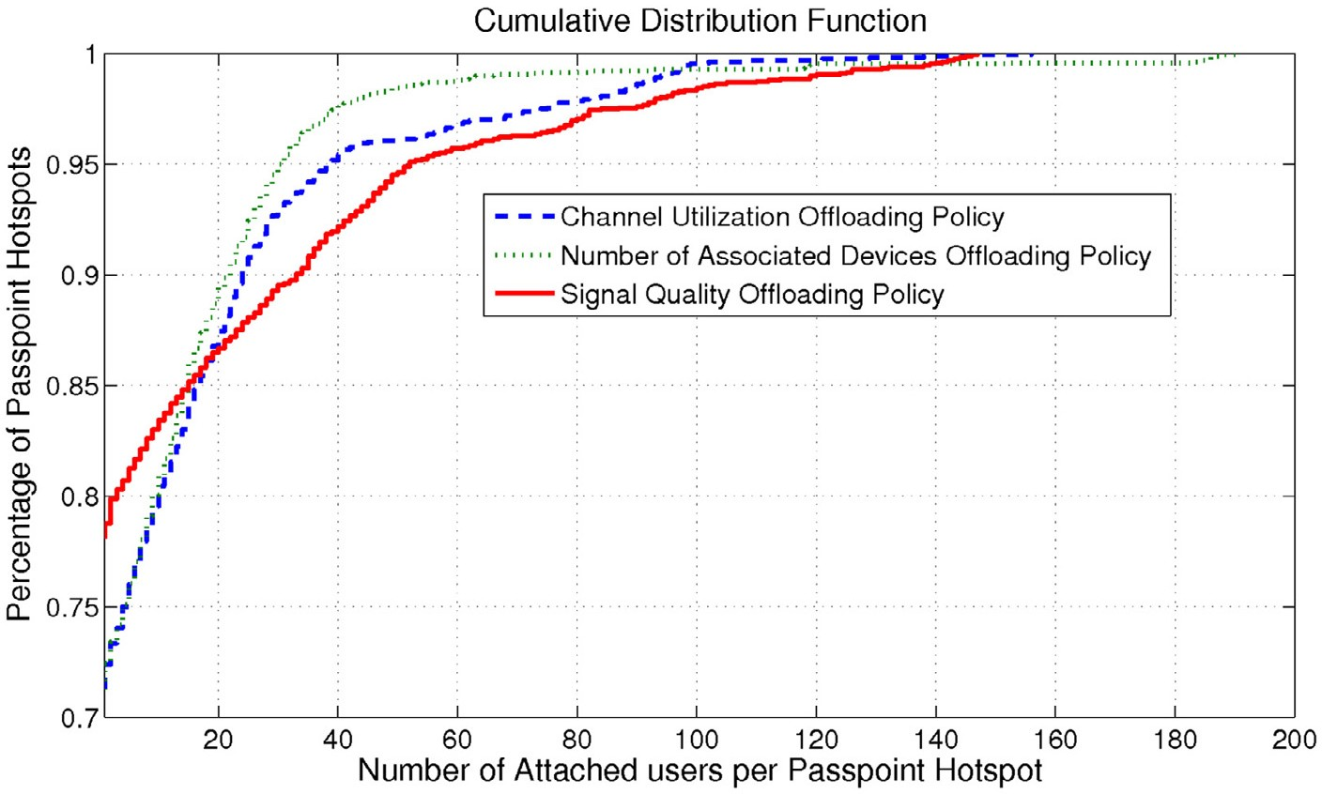

**Fig. 7.** CDF of the number of attached users per Passpoint hotspot (density of 80 hotspots/km2).

* + - The *Channel Utilization* oﬄoading policy outperforms the other ones and offers the highest capacity gain. A reason- able justiﬁcation of this behavior is that this policy equally distributes the users to hotspots taking into account traf- ﬁc volume and hence allowing hotspot resources to be eﬃciently utilized.
    - With the *Signal Quality* oﬄoading policy, all users in a

close location are assigned to the same hotspot because they will all receive AP signals with the same power. As a result, there will be a larger number of users competing for limited resources in the unilaterally best hotspot whereas the resources in the other hotspots remain free and hence wasted.

* + - The *Number of Associated Devices* oﬄoading policy does

not take into account the traﬃc volume required by each user and thus ineﬃciently distributes the users to hotspots.

* + - We can clearly see that the slope of the curve correspond- ing to the*Signal Quality* oﬄoading policy is higher than the other two policies. For instance, for a density of 200

using the three oﬄoading policies (for a hotspot density of 80 hotspots/km2). We notice that the percentage of low- loaded hotspots is higher for the *Signal Quality* oﬄoading policy than for the other two policies (e.g., in the *Signal Qual- ity* oﬄoading policy, approximately 80% of Passpoint hotspots have less than four attached users while 73% of hotspots have this value in the other two policies). Also 77% of hotspots oﬄoading each less than 1 MB of traﬃc in *Signal Quality* while 71% and 72.5% in *Channel Utilization* and *Number of Associated Devices* respectively. Moreover, the percentage of highly-loaded hotspots is bigger in *Signal Quality* oﬄoading policy than the other two policies. This means that the users are more concentrated in a small selection of hotspots in the *Signal Quality* oﬄoading policy whereas in the other two poli- cies, the users are distributed among more hotspots.

To ensure the latter property, we evaluate the fairness dis- tribution of the three policies in terms of number of attached users and traﬃc volume, using the Jain’s fairness index *JI* [31], deﬁned as:

hotspots/km2, we notice that the difference between the different policies decreases. This means that the advan- tages of using the SINR as an oﬄoading metric increase with the hotspot density but it remains lower than those

*JI* =

. *N*

*i*=1

.

Σ2 , .

*xi*

*N*

*N*

2

*x*

Σ

.

*i*

*i*=1

(3)

obtained by the other metrics.

* + - The differences between the *Channel Utilization* and the *Number of Associated Devices* oﬄoading policies are not so remarkable; this is due to the more or less homogenous data traﬃc distribution among the users in the considered region. As a matter of fact, as we have seen in Fig. 3, only 3% of users have high data traﬃc volume whereas the rest of 97% of users have a very low data traﬃc. With a more heterogeneous data traﬃc distribution, we could expect a higher difference between the two policies.

Furthermore, Figs. 7 and 8 show, respectively, the cu- mulative distribution function of the number of users at- tached as well as the traﬃc volume per Passpoint hotspot

where *N* represents the total number of hotspots in the re- gion and *xi* is either the number of attached users to hotspot *i* or the oﬄoaded traﬃc volume to hotspot *i*. These results are reported in Fig. 9, we can clearly see that while the *Number of Associated Devices* oﬄoading policy offers the highest fairness in terms of number of attached users, the *Channel Utilization* outperforms the others in terms of traﬃc volume. Moreover, we can notice that the *Signal Quality* policy offers the most unfair distribution of users and resources among the different hotspots. Furthermore, we can easily see that the fairness in- dexes in terms of number of attached users and traﬃc volume decrease with the increase of hotspots density. This can be interpreted by the fact that, as the hotspot density increases, the user will have more choices for the selection of hotspots

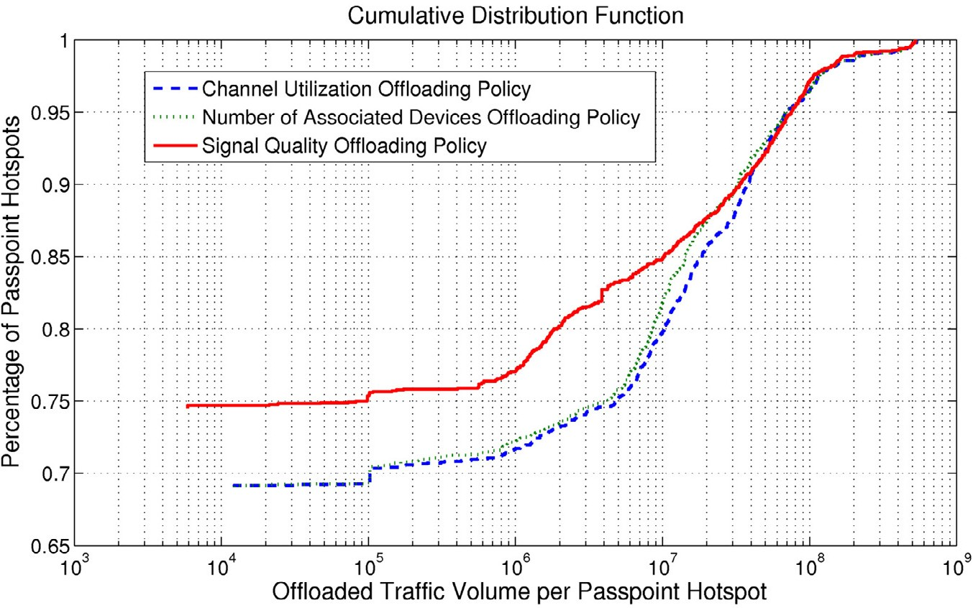

**Fig. 8.** CDF of oﬄoaded traﬃc volume per Passpoint hotspot (density of 80 hotspots/km2).

and this leads to higher unfairness. For example, suppose we have a user that enters the coverage zone of:

* + - * Scenario *A*: *N* different hotspots.
      * Scenario *B*: *N*j different hotspots such that (*N*j S *N*).

By applying Formula (3), the fairness index of the distribu- tion of users among the *N* hotspots is equal to 1 in Scenario *A*, while it decreases to 1 in Scenario *B*. The same reasoning applies for the traﬃc volume distribution.

*N*

j*N*

It is worth mentioning that the decrease of the fairness index with the hotspots density does not happen at the same rate for both the number of attached users and the traﬃc volume. This is due to the higher standard deviation of the traﬃc compared to the number of attached users (e.g., for a density of 60 hotspots/km2*,* the *Channel Utilization* oﬄoading policy leads to a distribution of traﬃc among the hotspots in which the standard deviation is equal to 6.24*e* + 07, while

the distribution of the users has a standard deviation equal

to 10.14).8 All these results conﬁrm the previous ﬁndings and emphasize the more eﬃcient usage of resources and dis- tribution of traﬃc among different hotspots in the *Channel Utilization* oﬄoading policy.

All in all, starting from a discrete Passpoint hotspot den- sity, the gain of using the best among Passpoint oﬄoading policies (i.e., the Channel Utilization one) and the oﬄoading policy implementable without Passpoint (the Signal Quality one) is of roughly 15%.9 These results are obtained for a ran- dom distribution of Passpoint hotspots, so the next question to answer is what is the most appropriate hotspot placement scheme.

8 The higher the standard deviation is, the higher the inequity of the dis- tribution becomes.

9 It is worth mentioning that besides capacity gain, we can compare the

oﬄoading policies in terms of throughput, delay, etc. However the results of fairness analysis, presented previously, allow us to expect the behavior of the different oﬄoading policies.

* 1. *Passpoint placement schemes*

We compare different Passpoint placement schemes in or- der to assess the impact of Passpoint positions on the oﬄoad- ing system performance. Given the base station antenna- centric nature of cellular access, and more generally of wireless access, we consider different placement schemes de- pending on a parameter expressing the Distance To Borders (DTB) deﬁned as:

distance*(Pi,* ♦*j) i,j* distance*(M ,* ♦ *)*

DTB = (4)

*j j*

where:

*Pi* is the *i*th Passpoint and *Mj* is the *j*th macrocell in the region.

♦*j* is the polygon that surrounds the coverage area of Macrocell *j*.

distance*(Pi,* ♦*j)* is the minimal distance from the Passpoint

*Pi* to all ribs of ♦*j*.

Based on the DTB parameter, we select four different placement schemes, presented in Fig. 10 where the col- ored zone represents the region of installing the Passpoint hotspots. We consider the placement of Passpoint hotspots in the:

* + - outer annulus (i.e., zone close to the edge) of the macrocell coverage, with a DTB between 0 and 0.33, as in Fig. 10(a);
    - middle annulus (i.e., central zone) of the macrocell cover- age, with a DTB between 0.33 and 0.66, as in Fig. 10(b);
    - inner annulus (i.e., zone closest to the base station) of the macrocell coverage, with a DTB between 0.66 and 1, as in Fig. 10(c);
    - whole macrocell zone, randomly distributed, with a DTB between 0 and 1, as in Fig. 10(d).

Fig. 11 illustrates the results obtained by varying the hotspot placement schemes. We consider here the *Channel*

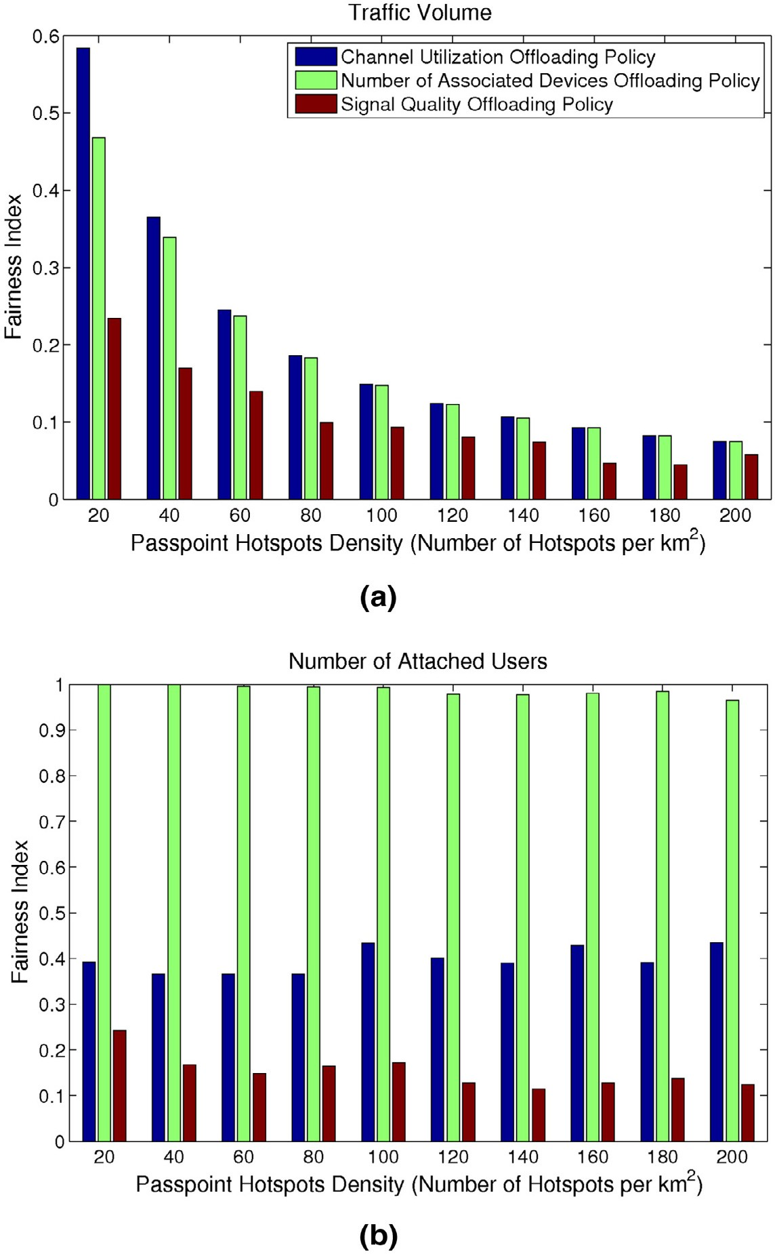

**Fig. 9.** Jain’s fairness index of the three oﬄoading policies as a function of the traﬃc volume and the number of users.

*Utilization* policy which appears as the best Passpoint oﬄoad- ing policy. We can clearly notice that:

* + - The hotspot placement with DTB between 0 and 0.33 (i.e., installing Passpoint hotspots in the outer annulus of the macrocell coverage) is the best placement scheme, which guarantees the highest capacity gain. The interpretation is straightforward as users located at the edge of the macro- cell base station suffer from a low SINR; therefore, the modulation chosen for those users is the one that requires the least number of bits per symbol (i.e., QPSK modulation in our case) to reduce the symbol error rate. Those users have low bit rates and thus require more time and more RBs to transmit their traﬃc. By oﬄoading their traﬃc to

Passpoint hotspots, we free a big number of RBs from the cellular networks.

* The topology corresponding to DTB between 0.66 and 1 (i.e., inner annulus) is the worst among others. Differ- ently than for the outer annulus case, users close to the macrocell base station use the modulation that requires the highest number of bits per symbol: those users have a high bit rate and require less time and RBs. So oﬄoading their traﬃc is not very beneﬁcial for cellular networks.
* The topology corresponding to DTB between 0 and 0.33 overcomes the random one (DTB between 0 and 1) with a mean capacity gain of roughly 5%, and that with DTB between 0.33 and 0.66 (i.e., central annulus) with a mean gain of roughly 3%.

# 

(a) DTB between 0 and 0.33 (b) DTB between 0.33 and 0.66

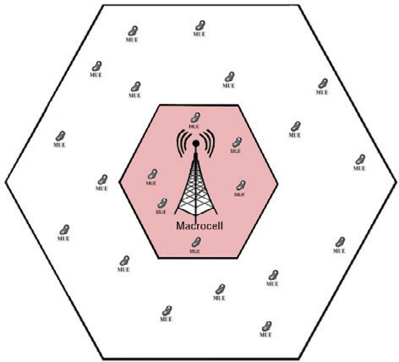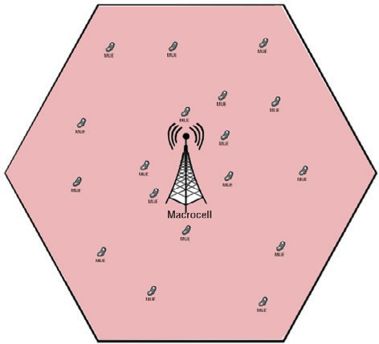

(c) DTB between 0.66 and 1 (d) DTB between 0 and 1

**Fig. 10.** Illustration of different hotspot placement schemes.

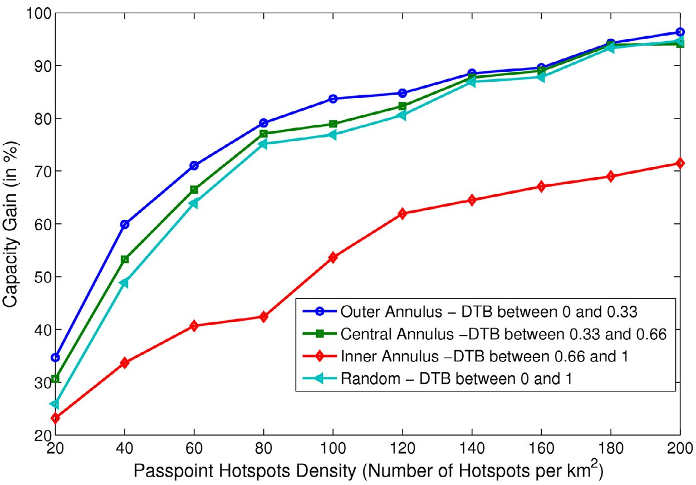

**Fig. 11.** Capacity gain for different hotspot placement schemes under the best hotspot selection policy.

It is worth mentioning that the results of the best place- ment study are not quite surprising. However, as we try to compute the highest capacity gain that one can get using this Passpoint program and since this gain depends strongly on the hotspots’ positions, the latter study enables a further anal- ysis on the comparison of different oﬄoading policies under the best hotspot placement scheme, i.e., the case where Pass- point hotspots are placed only in the outer annulus. Fig. 12 illustrates the obtained results, where the dotted lines re- fer to the random hotspot placement replicated from Fig. 6.

The ﬁgure shows that the gap between Passpoint policies and the signal quality policy is further increased when placing the hotspot in the outer annulus only. We notice a mean differ- ence between the outer and random placement schemes of around 11% for low hotspots density and this difference de- creases for high hotspots density with a mean difference of around 3%. Overall, with hotspot placement in the outer an- nulus, the gain increases when using the Passpoint-enabled oﬄoading policies rather than the signal quality one and this gain is around 15%.

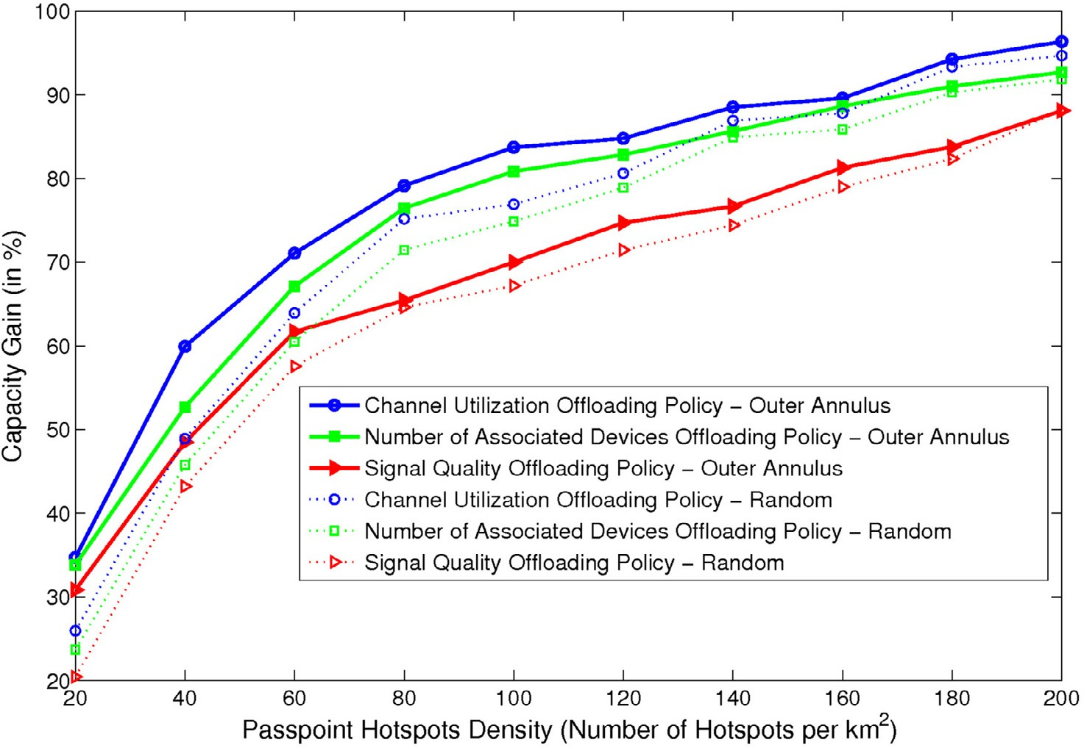

**Fig. 12.** Capacity gain for different Passpoint hotspot selection policies under the best placement scheme.

* 1. *Sensibility analysis*

The results obtained so far, proved that the usage of the *Channel Utilization* metric as an oﬄoading policy shows the best overall performance in terms of fairness and capacity gain. An important research question may arise here, does the combination of some metrics together permit further bene- ﬁts in terms of capacity? To answer this question, we are interested in evaluating the capacity gain obtained from the combination of different oﬄoading policies. The combined policy can be seen as follows:

*C(Pi, Pj)* = *α* ∗ *Pi* + *(*1 − *α)* ∗ *Pj* (5) where *Pi* and *Pj* are the policies to combine; *C*(*Pi*, *Pj*) is the

result of the combination between policy*i* and policy*j*. More- over, *α* and (1−*α)* are the weights of policy*i* and policy*j,*

respectively. In our study, we take an equal weight for the two combined policies (i.e., *α* = 1 − *α* = 0.5). Since, we have three different policies (*Channel Utilisation*, *Number of Associ- ated Devices* and *Signal Quality*), we can obtain three different combined policies. We note that in the combined policy, the

selected hotspot for oﬄoading user’s data traﬃc is the one having the highest value in Eq. 5.

Fig. 13 shows the obtained results for the different cases under the best placement scheme (i.e., the outer annulus). We can clearly notice that the capacity gain resulting from the combination of the different policies sits in-between those obtained by the two separated policies.

Furthermore, we evaluate the sensibility of the oﬄoading policies by varying the weights attributed to the combined policies, Fig. 14 shows the result of combining the *Channel Utilization* and the *Number of Associated Devices* oﬄoading

policies using different weights (i.e., *α*) under the best place-

ment scheme (i.e., the outer annulus) and for a hotspot den-

sity of 80 hotspots/km2. We can clearly see that the capacity gain of the combined policy varies between those of the *Chan- nel Utilization* and the *Number of Associated Devices* policies. When *α* = 0; the combined policy has a capacity gain equal to that of the *Number of Associated Devices* oﬄoading policy while for *α* = 1; the combined policy offers a gain equal to that of the *Channel Utilization* policy. We note that a quite similar behavior can be seen for the other combined policies. All in all, we can say that the combination of some metrics together increases the overall capacity gain but the latter remains bounded by the one obtained through the *Channel Utilization* oﬄoading policy.

* 1. *Delay tolerance sensibility*

As a ﬁnal analysis, we are interested in evaluating the ef- fect of varying the traﬃc delay tolerance Thmax on the overall performance. For the simulations, we consider the *Channel Utilization* oﬄoading policy under the best placement scheme for a density of 80 hotspots/km2. We compute the capacity gain by varying the Thmax from 10s to6 min.10 The results of this study are presented in Fig. 15, we can clearly notice that the capacity gain increases with the increase of Thmax as the traﬃc has higher probability to be oﬄoaded over a Passpoint hotspot when its delay tolerance increases. Overall, we notice an increase of the capacity by 17% when changing the max- imum delay tolerance from 10 s to 6 min. We note that the same results are obtained for the different oﬄoading policies, under different placement schemes.

10 The maximum delay tolerance is upper bounded by the value of 6 min because the data used in our analysis are decomposed into 6-min interval sessions as explained in Section 3.

# 

1. Combination between *Channel Utiliza- tion* and *Number of Associated Devices* of- floading policies
2. Combination between *Channel Utiliza- tion* and *Signal Quality* offloading policies

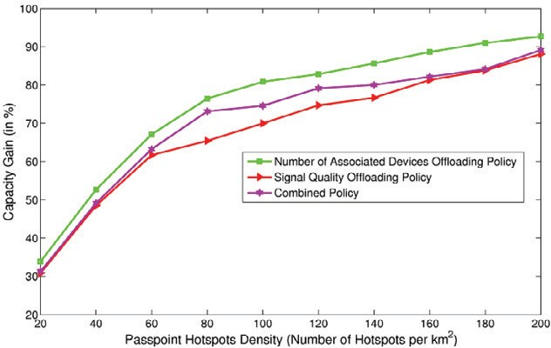

1. Combination between *Number of Asso- ciated Devices* and *Signal Quality* off loading policies

**Fig. 13.** Combination of the different policies under the best placement scheme (for a weight = 0.5).

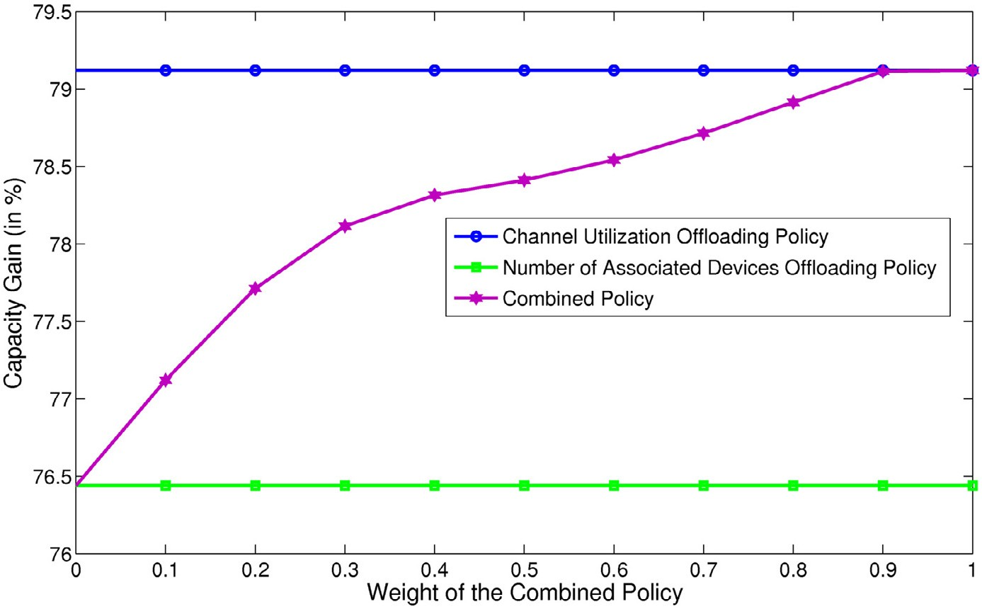

**Fig. 14.** Capacity gain for different weights under the best hotspot placement scheme (for a density of 80 hotspots/km2).

* 1. *Energy saving gain*

Thus far, we have studied the capacity gain that an opera- tor can get by oﬄoading data traﬃc over Passpoint hotspots but what about the gain from users’ point of view? Does this oﬄoading solution increase the battery lifetime of mobile phones?

We therefore study whether oﬄoading mobile data traf- ﬁc over Passpoint hotspots is worthwhile, in terms of energy.

The power consumption values for LTE and WiFi systems are computed based on local experiments done by the au- thors of [32] on an LTE phone. These values are presented in Table 4, where *αu* represents the uplink power consump- tion per Mb/s (i.e., the power needed in mW for sending data at a throughput of 1 Mb/s), *αd* is the downlink power consumption per Mb/s (i.e., the power needed in mW for re- ceiving data at a throughput of 1 Mb/s) and *β* is the baseline power. For example, the power consumption of a given user

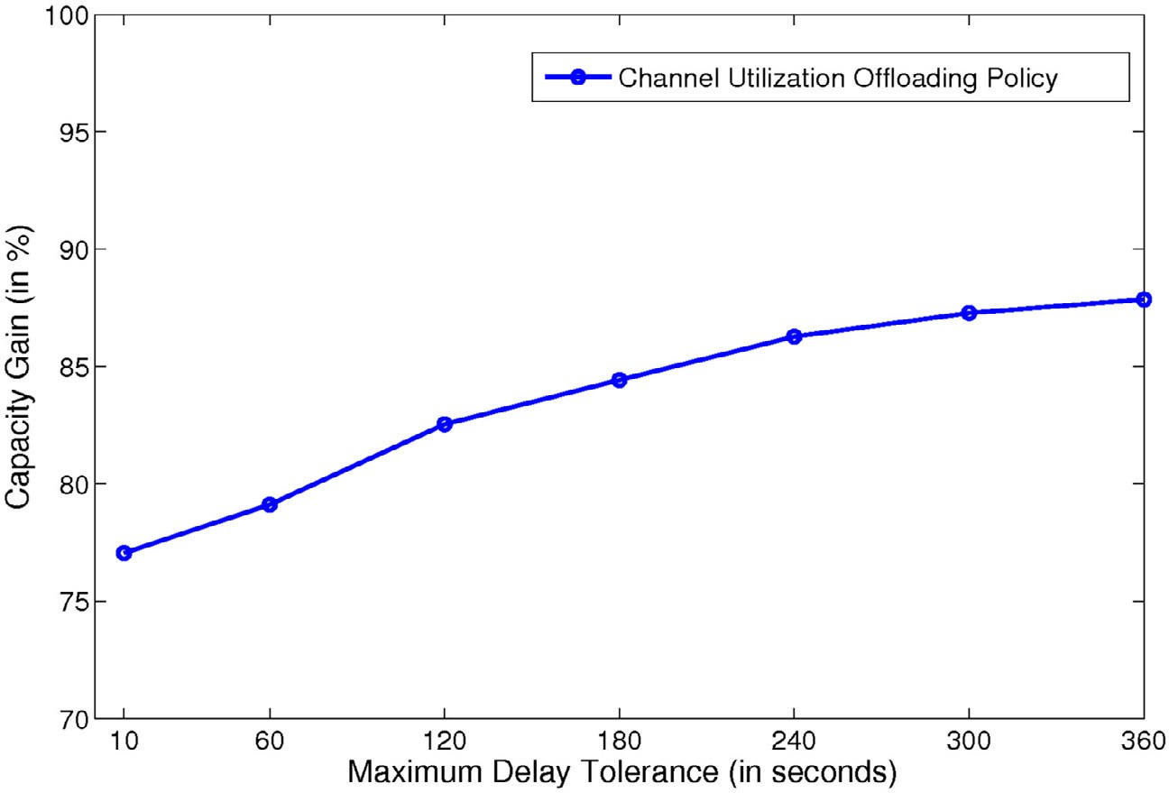

**Fig. 15.** Capacity gain for the Channel Utilization Oﬄoading Policy as a function of different delay tolerance thresholds under the best hotspot placement scheme (for a density of 80 hotspots/km2).

60

Channel Utilization

Number of Associated Devices Signal Quality

50

40

Energy Saving Gain (in %)

30

20

10

0 20 40 60 80 100 120 140 160 180 200

Passpoint Hotspots Density (Number of Hotspots per km2)

**Fig. 16.** Energy saving of oﬄoading mobile data traﬃc over Passpoint hotspots for different oﬄoading policies.

**Table 4**

Power consumption of a smartphone networking interfaces [32].

|  |  |  |  |
| --- | --- | --- | --- |
|  | *αu* (mW/(Mb/s)) | *αd* (mW/(Mb/s)) | *β* (mW) |
| LTE | 438.39 | 51.97 | 1288.04 |
| WiFi | 283.17 | 137.01 | 132.86 |

in the LTE cellular network for the downlink transmission is given by:

*Pd* = *β* + *αdtd* (6)

where *β* is equal to 1288.04 mW, *αd* = 51.97 mW/(Mb/s), and *td* represents the downlink data rate (in Mb/s) for the user over the LTE interface, which depends on the allocated RBs

and the channel quality experienced by the user. The same formula holds for the power consumption in WiFi networks, we only replace the parameters *β* and *αd* by the values in the second line of Table 4. We deﬁne the Energy Saving Gain (ESG) as follows:

### Energy Consumption with Oﬄoading

ESG = 1 − Energy Consumption without Oﬄoading (7)

Fig. 16 shows the average energy saving in percentage (i.e., average energy saving of all users in the region) that one can get by oﬄoading mobile data traﬃc over Passpoint hotspots for different oﬄoading policies. The same dataset of the previous simulations is used. As before, the hotspots are randomly distributed. We can clearly notice that:

* + - The energy is better saved when the number of Passpoint hotspots increases, as the probability that a user encoun- ters a Passpoint and thus oﬄoads its data traﬃc over Pass- point increases.
    - The *Signal Quality* oﬄoading policy is less energy-eﬃcient

than the other two and its energy saving gain seems to in- crease at slower rates compared to the other two policies. This behavior can be explained by the higher percent- age of highly-loaded hotspots in *Signal Quality* oﬄoading policy compared to the other two policies as reported in Figs. 7 and 8. Thus with the *Signal Quality* oﬄoading pol- icy, users compete more with each other to get access to the selected hotspot and end up sometimes without be- ing able to transfer their traﬃc over that hotspot, which results in a waste of energy.

* + - The *Channel Utilization* oﬄoading policy outperforms the

other policies in terms of energy consumption and saves from 23% of energy in low hotspots density to 52% in high hotspots density. It saves up to 3% and 13% of energy comparing to the *Number of Associated Devices* and *Signal*

*Quality* policies.

All in all we can emphasize the strength of oﬄoading mo- bile data traﬃc over Passpoint hotspots in terms of both user’s device and spectrum capacity gain from the cellular network operator.

#### Conclusions

Traﬃc growth is outstripping the capacity of cellular mo- bile networks, especially in urban and densely populated zones. Moreover, operators are under pressure to ﬁnd so- lutions to keep up with their customer’s insatiable demand for data intensive applications. Data traﬃc oﬄoading to Wi-Fi hotspots has always been an attractive solution for catering the increasing data demand in mobile networks, despite the existence of some drawbacks that limit their usage. Nowa- days, with the advent of the Passpoint program [5], oﬄoading data traﬃc to Passpoint hotspots is back to the forefront. The Passpoint program was created to address critical business needs for mobile data, streamline access and to help ease op- erator data traﬃc oﬄoad to these smart Wi-Fi networks in a completely transparent way for the user.

In this paper, we compare different conceivable mobile data traﬃc oﬄoading over Passpoint hotspots to each other and to baseline approaches, using real mobile consumption data gathered from the Orange mobile network in Paris. First, we provide a brief analysis of mobile data consumption and characteristics. Then, we compute the capacity gain as well as the energy saving gain that one can get by oﬄoading users traﬃc while taking into account different oﬄoading policies and hotspot placement schemes.

In particular, we show that oﬄoading using Passpoint control-plane information can grant up to 15% capacity gain and 13% energy saving gain with respect to Passpoint- agnostic ones based on signal quality information. As of our knowledge, our study is the ﬁrst one quantifying the achiev- able cellular traﬃc oﬄoading gain to Passpoint hotspots using the additional information given by Passpoint, via the ANQP protocol to mobile users, for hotspot selection.

As a future work, we aim to investigate new oﬄoading policies by exploiting the additional information provided by the Passpoint hotspots to the end users.

#### Acknowledgments

This work was partially supported by the ANR ABCD project (grant no. ANR-13-INFR-005), and by the EU FP7 IRSES MobileCloud Project (grant no. 612212).

#### References

1. [S. Hoteit, S. Secci, G. Pujolle, S. Wietholter, A. Wolisz, C. Ziemlicki, et al., Quantifying the achievable cellular traﬃc oﬄoading gain with pass- point hotspots, in: Proceedings of ACM International Workshop on Wireless and Mobile Technologies for Smart Cities, Philadelphia, PA, USA, 2014.](http://refhub.elsevier.com/S1389-1286(15)00136-X/sbref0001)
2. Cisco, San Jose, CA, Cisco visual networking index: Global mobile data [traﬃc forecast update, 2012–2017, 2013. http://www.cisco.com/en/ US/solutions/collateral/ns341/ns525/ns537/ns705/ns827/white_paper](http://www.cisco.com/en/US/solutions/collateral/ns341/ns525/ns537/ns705/ns827/white_paper_c11-520862.pdf)

[_c11-520862.pdf.](http://www.cisco.com/en/US/solutions/collateral/ns341/ns525/ns537/ns705/ns827/white_paper_c11-520862.pdf)

1. D. Srinivasan, J. Dey, S. Kumar, R.N. Mukherjee, Data Oﬄoad Approaches for Mobile Operators: Improving Network Eﬃciency and Strengthening Quality of Service, 2012, Wipro Technologies.
2. [W. Lehr, L.W. Mcknight, Wireless internet access: 3g vs. wiﬁ? Telecom- mun. Policy 27 (2003) 351–370.](http://refhub.elsevier.com/S1389-1286(15)00136-X/sbref0002)
3. Wi-ﬁ certiﬁed passpoint architecture for public access, 2012, White Paper, Aruba Networks.
4. Wi-Fi Alliance, Launch of wi-ﬁ certiﬁed passpoint enables a new era in service provider wi-ﬁ, 2012, Austin, TX.
5. [S. Dimatteo, P. Hui, B. Han, V. Li, Cellular traﬃc oﬄoading through wiﬁ networks, in: Proceedings of IEEE International Conference on Mobile Adhoc and Sensor Systems (MASS), 2011.](http://refhub.elsevier.com/S1389-1286(15)00136-X/sbref0003)
6. A. Schumacher, J. Schlienz, WLAN Traﬃc Oﬄoad in LTE, Rohde & Schwarz white paper, November 2012.
7. Femto forum, Femtocell—Natural solution for oﬄoad, 2010, White pa- per.
8. Femto Forum, Challenges in the deployment of UMTS/HSPA femtocell, White Paper, Aricent, February 2008.
9. [J.G. Andrews, H. Claussen, M. Dohler, S. Rangan, M. Reed, Femtocells: Past, present, and future, IEEE J. Select. Area Commun. 30 (3) (2012) 497–508.](http://refhub.elsevier.com/S1389-1286(15)00136-X/sbref0004)
10. [J. Roh, Y. Ji, Y.G. Lee, I. Rhee, T. Ahn, Femtocell traﬃc oﬄoad scheme for core networks, in: 4th IFIP International Conference on New Technolo- gies, Mobility and Security (NTMS), Paris, 2011.](http://refhub.elsevier.com/S1389-1286(15)00136-X/sbref0005)
11. [D. Lopez-Perez, A. Ladanyi, A. Juttner, J. Zhang, Ofdma femtocells: In- tracell handover for interference and handover mitigation in two-tier networks, in: Proceedings of Wireless Communications and Network- ing Conference WCNC, 2010.](http://refhub.elsevier.com/S1389-1286(15)00136-X/sbref0006)
12. [V. Chandrasekhar, J. Andrews, Spectrum allocation in tiered cellular networks, IEEE Trans. Commun. 57 (10) (2009) 3059–3068.](http://refhub.elsevier.com/S1389-1286(15)00136-X/sbref0007)
13. [S. Hoteit, S. Secci, R. Langar, G. Pujolle, R. Boutaba, Bankruptcy game approach for resource allocation in cooperative femtocell networks, in: IEEE Global Communications Conference (IEEE GLOBECOM’12), Ana- heim, CA, USA, 2012.](http://refhub.elsevier.com/S1389-1286(15)00136-X/sbref0008)
14. [A. Hatoum, N. Aitsaadi, R. Langar, R. Boutaba, G. Pujolle, Fcra: Femto- cell cluster-based resource allocation scheme for OFDMA networks, in: Proceedings of IEEE ICC, 2011.](http://refhub.elsevier.com/S1389-1286(15)00136-X/sbref0009)
15. [K. Sundaresan, M. Arslan, S. Singh, S. Rangarajan, S. Krishnamurthy, Fluidnet: a ﬂexible cloud-based radio access network for small cells, in: Proc. of the 19th annual international conference on Mobile computing and networking (MobiCom 2013), Miami, USA, 2013.](http://refhub.elsevier.com/S1389-1286(15)00136-X/sbref0010)
16. [A. Balasubramanian, R. Mahajan, A. Venkataramani, Augmenting mo- bile 3g using wiﬁ, in: Proceeding of ACM MOBISYS, 2010.](http://refhub.elsevier.com/S1389-1286(15)00136-X/sbref0011)
17. [K. Lee, J. Lee, Y. Yi, I. Rhee, S. Chong, Mobile data oﬄoading: How much can wi-ﬁ deliver? IEEE/ACM Trans. Netw. 21 (2) (2013).](http://refhub.elsevier.com/S1389-1286(15)00136-X/sbref0012)
18. [S. Wietholter, M. Emmelmann, R. Andersson, A. Wolisz, Performance evaluation of selection schemes for oﬄoading traﬃc to ieee 802.11 hotspots, in: Proceedings of IEEE International Conference on Commu- nications (ICC), 2012.](http://refhub.elsevier.com/S1389-1286(15)00136-X/sbref0013)
19. [A. Aijaz, O. Holland, P. Pangalos, H. Aghvami, Energy savings for cellular access network through wi-ﬁ oﬄoading, in: Proc. of IEEE International Conference on Communications, ICC, 2012.](http://refhub.elsevier.com/S1389-1286(15)00136-X/sbref0014)
20. [X. Hou, P. Deshpande, S.R. Das, Moving bits from 3g to metro-scale wiﬁ for vehicular network access: An integrated transport layer solution, in: Proceedings of IEEE ICNP, Vancouver, Canada, 2011.](http://refhub.elsevier.com/S1389-1286(15)00136-X/sbref0015)
21. X. Zhuo, W. Gao, G. Cao, Y. Dai, Win-coupon: An incentive framework for 3g traﬃc oﬄoading, in: Proceedings of the IEEE ICNP 2011.
22. [D. Zhang, C.K. Yeo, Optimal handing-back point in mobile data oﬄoad- ing, in: IEEE Vehicular Networking Conference (VNC), 2012.](http://refhub.elsevier.com/S1389-1286(15)00136-X/sbref0016)
23. [O. Yilmaz, A. Furuskar, J. Pettersson, A. Simonsson, Access selection  in wcdma and wlan multi-access networks, in: Proceedings of IEEE Vehicular Technology Conference (VTC), 2005.](http://refhub.elsevier.com/S1389-1286(15)00136-X/sbref0017)
24. [S. Hoteit, S. Secci, S. Sobolevsky, C. Ratti, G. Pujolle, Estimating human trajectories and hotspots through mobile phone data, Elsevier Comput. Netw. 4 (2014) 296–307.](http://refhub.elsevier.com/S1389-1286(15)00136-X/sbref0018)
25. [C. Mueller, S. Lederer, C. Timmerer, An evaluation of dynamic adaptive streaming over http in vehicular environments, in: Proceedings of the 4th Workshop on Mobile Video (MoVid12), 2012.](http://refhub.elsevier.com/S1389-1286(15)00136-X/sbref0019)
26. COST Action 231, Digital mobile radio towards future generation sys- tems, ﬁnal report, 1999, Technical Report, European Communities, EUR 18957.
27. [M. Hata, Empirical formula for propagation loss in land mobile radio services, IEEE Trans. Veh. Technol. VT-29 (1981) 317–325.](http://refhub.elsevier.com/S1389-1286(15)00136-X/sbref0020)
28. M. Burton, Channel overlap calculations for 802.11b networks, 2002, White Paper, Cirond Technologies Inc.
29. R. Jain, W. Hawe, D. Chiu, A quantitative measure of fairness and dis- crimination for resource allocation in shared computer systems, 1984, DEC Research Report TR-301.
30. [J. Huang, F. Qian, A. Gerber, Z. Mao, S. Sen Sen, O. Spatscheck, A close ex- amination of performance and power characteristics of 4g lte networks, in: Proceedings of Mobysis, 2012 .](http://refhub.elsevier.com/S1389-1286(15)00136-X/sbref0021)

**Sahar Hoteit** is currently a Postdoctoral Re- searcher at the LSS (Laboratoire de Signaux et Sys- tèmes) Centrale-SUPELEC, Gif sur Yvette, France. She received the Diploma in electrical, electron- ics, computer and telecommunications engineer- ing from Lebanese University, Beirut, Lebanon, in 2010; the M.S. degree in computer science from the University of Pierre and Marie Curie, France, in 2011 and the Ph.D. degree in computer sci- ence and networks from University Pierre and Marie Curie in 2014. She was a visiting researcher at Senseable City Lab, Massachusetts Institute of Technology MIT, Cambridge, USA in 2012 and at

the Telecommunication Networks group in the Technical University of Berlin, Germany in 2013. Her research interests include power and resource man- agement in wireless networks, human mobility analysis and cloud comput- ing.

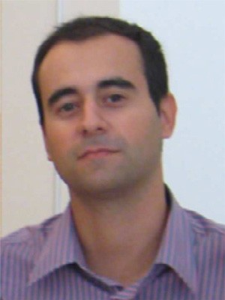**Stefano Secci** is an associate professor at the Uni- versity Pierre and Marie Curie (UPMC—Paris VI, Sorbonne Universities). He received a “Laurea” degree in telecommunications engineering from Politecnico di Milano, in 2005, and a dual Ph.D. de- gree in computer networks from the same school and Telecom ParisTech, in 2009. He also worked as a research fellow at NTNU, George Mason Uni- versity, Ecole Polytechnique de Montreal, and Po- litecnico di Milano, and as a network engineer with Fastweb Italia. His works mostly cover net- work modeling and optimization, protocol design,

Internet traﬃc engineering. He is Vice-Chair of the IEEE Communications Society/Internet Society (ISOC) Internet Technical Committee (ITC).

**Guy Pujolle** is a professor at Pierre et Marie Curie University—Paris 6. He spent the period 1994–2000 as professor and head of the com- puter science department of Versailles Univer- sity. He was also professor and head of the MASI Laboratory at Pierre et Marie Curie Uni- versity (1981–1993), professor at ENST (1979– 1981), and a member of the scientiﬁc staff of IN- RIA (1974–1979). He is an editor for ACM Interna- tional Journal of Network Management, Telecom- munication Systems, and editor in chief of Annals of Telecommunications. He is a pioneer in high-speed networking having led the devel-

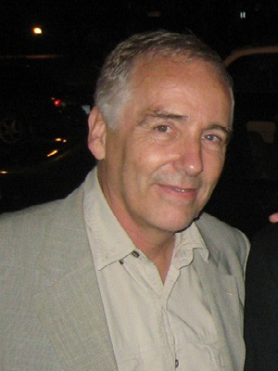opment of the ﬁrst Gb/s network to be tested in 1980. He was partic- ipating in several important patents like DPI or virtual networks. He is co-founder of QoSMOS ([http://www.qosmos.fr](http://www.qosmos.fr/)), Ucopia Communications ([http://www.ucopia.com](http://www.ucopia.com/)), EtherTrust ([http://www.ethertrust.com](http://www.ethertrust.com/)), Virtuor [(http://www.VirtuOR.fr), and Green Communications (http://www.green- communications.fr).](http://www.green-communications.fr/)

**Adam Wolisz** received his degrees (Diploma 1972, Ph.D. 1976, Habil. 1983) from Silesian Uni- versity of Technology, Gliwice, Poland. He joined TU Berlin in 1993, where he is a chaired profes- sor in telecommunication networks and execu- tive director of the Institute for Telecommuni- cation Systems. He is also an adjunct professor at the Department of Electrical Engineering and Computer Science, University of California, Berke- ley. His research interests are in architectures and protocols of communication networks. Recently he has been focusing mainly on wireless/mobile networking and sensor networks.

**Cezary Ziemlicki** is an R&D engineer at Orange Labs, in the laboratory Sociology & Economics of Networks and Services, Issy-les-Moulineaux, France. A graduate of the Warsaw University of Technology in automation of industrial processes, he is a research engineer and joined Orange Labs in 2000. His work at Orange Labs is to develop methodologies of analysis of telco operator data for use in human sciences.

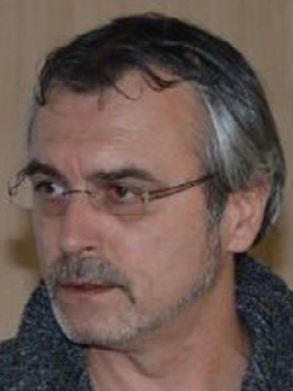**Zbigniew Smoreda** is a senior researcher at Or- ange Labs, Sociology and Economics of Networks and Services (SENSE) department. Before inte- grating Orange Labs (CNET) in 1995, he worked as an assistant professor with Warsaw University, a researcher and lecturer with GRIFS (Université de Paris 8), a researcher with Group d’Analyse Soci- ologique des Télécoms (France Télécom) and with Observatoire Mondial des Systèmes de Communi- cation (OMSyC). HisworkinOrangeLabsisrelated to sociology of communication and in particular to social uses of ITCs and social network forms and transformations associated with technologies.